CAM PHUC PRIMARY SCHOOL  Full Name: .............................  Class: 4..... | THE END SEMESTER TEST  SUBJECT: ENGLISH - GRADE 4  School year: 2022 - 2023  (Time: 40 minutes)
Listening | Reading&  writing | Speaking | FINAL MARK | Comments
PART I: LISTENING (4,5 points)
Task 1. Listen and tick (1,5 points)
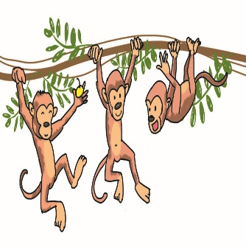 | 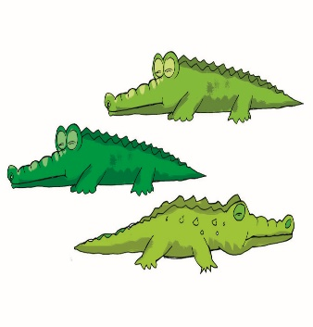 |  | 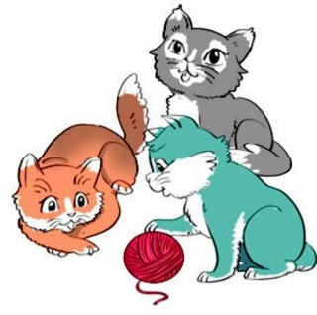
Example: a. | b. | 1. a. | b.
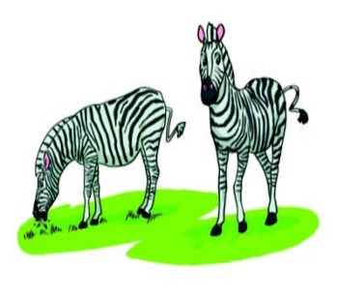 | 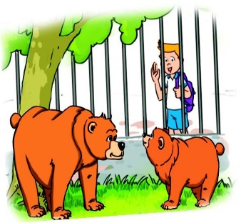 | 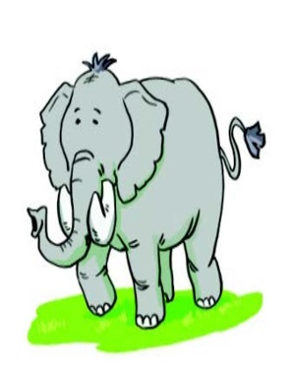 | 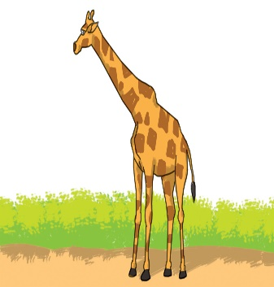
2. a. | b. | 3. a. | b.
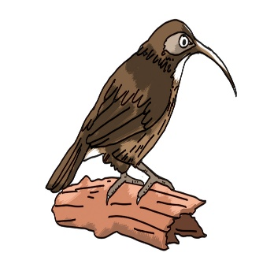 | 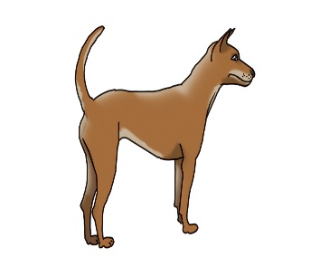 | 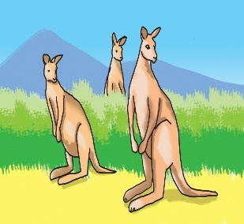 | 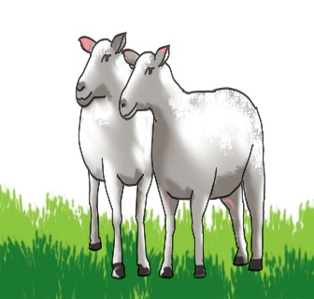
4. a. | b. | 5. a. | b.
Task 2. Listen and tick or cross . (1,5 points)
Examples: | 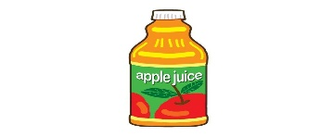 | 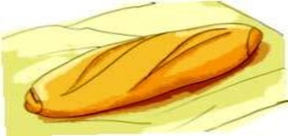
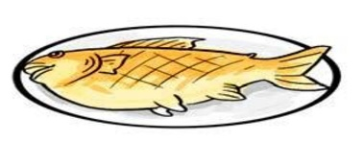 | 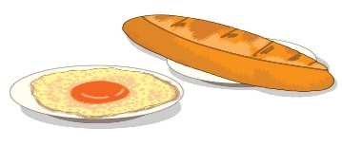 | 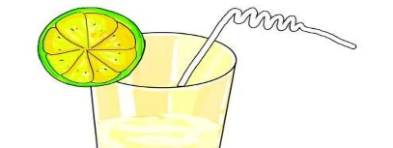
1. | 2. | 3.
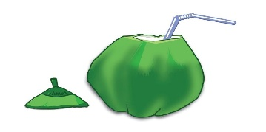 | 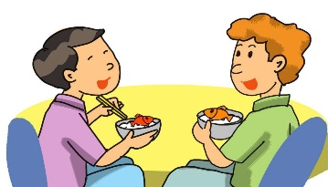
4. | 5.
Task 3. Listen and tick the correct pictures. There is one example (1,5 points).
0. Where does Jane go with her friends at weekends?
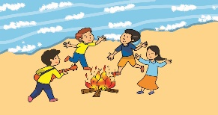  A. | 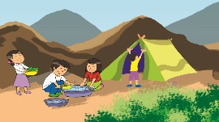  B. | 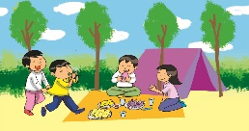  C.
1. What do the girls like doing?
A. | 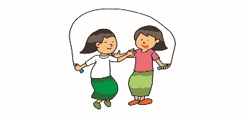  B. | 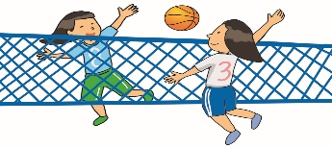  C.
2. What do the boys love doing?
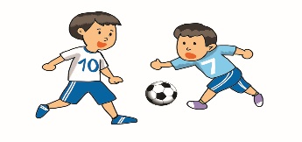  A. | 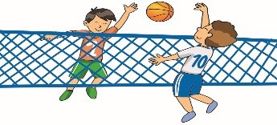  B. | 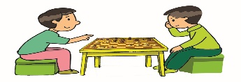  C.
3. What do some boys and girls like doing?
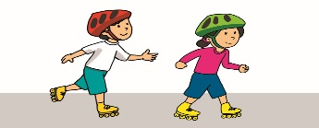  A. | 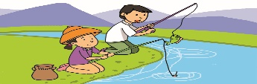  B. | 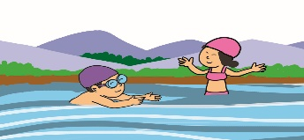  C.
4. How does Jane love taking photographs?
A. | B. | C.
5. What does Jane also enjoy doing?
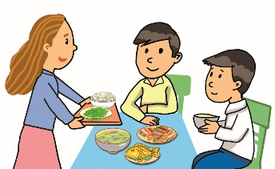  A. | 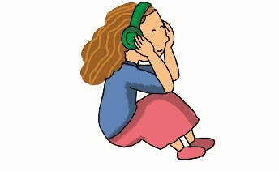  B. | C.
PART II: READING AND WRITING (4,5 points)
Task 4. Read and tick or cross . (1,5 points)
Examples: | 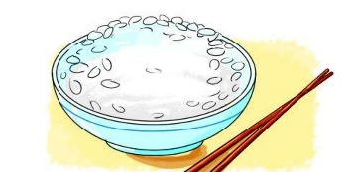 | 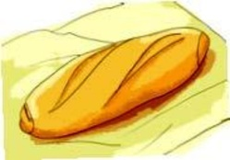
 | A. My favourite food is rice. | B. My favourite drink is orange juice.
 | 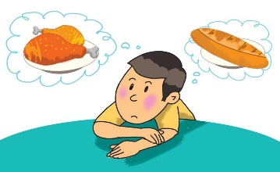 | 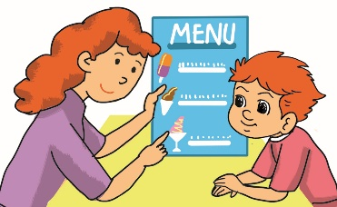
1. My favourite food is noodles. | 2. My younger brother likes bread and milk. | 3. Would you like some ice cream, Tony?
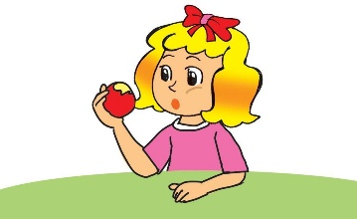 | 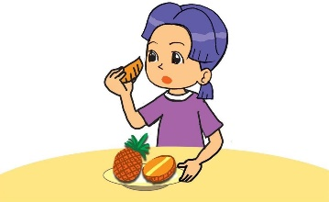
4. My favourite food is chicken. | 5. My favourite fruit is pineapple.

Task 5. Order the words. There is one example. (1,5 points)
Example: favourite / food / my / chicken / is
My favourite food is chicken.
1. you / would / some / fish / like / Susan
__________________________________________?
2. is / her / favourite / juice / orange / drink
___________________________________________
3. my / likes / brother / older / lemonade / much / very
___________________________________________
4. favourite / drink / what’s / your
__________________________________________?
5. like / rice / would / and / chicken / you / some
__________________________________________?

Task 6. Read and fill the gaps. There is one example (0). (1,5 points)
parents | 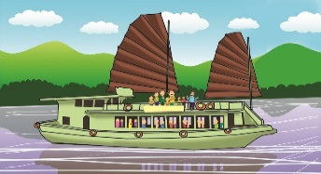  boat | 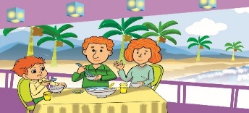  party
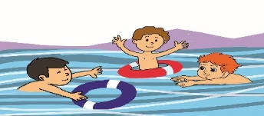  swim | 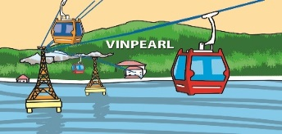  car | 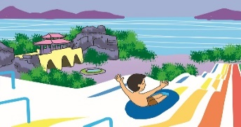  park

Tony and his (0) parents are going to Nha Trang this weekend. On Saturday morning, they are going to take a (1) ______ trip along the islands. In the afternoon, they are going to (2) ______ in the sea. On Sunday morning, they are going to Vinpearl Resort by cable (3) ______. They are going to visit the water (4) _______ and Tony is going to take a lot of photographs there. In the afternoon, they are going to have a (5) _____ in their hotel.
PART III. SPEAKING (1 point)
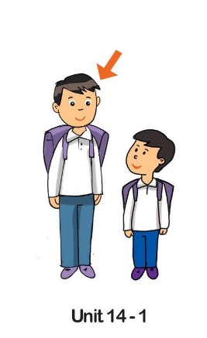 | 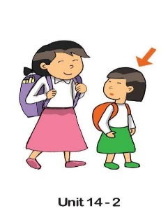 | 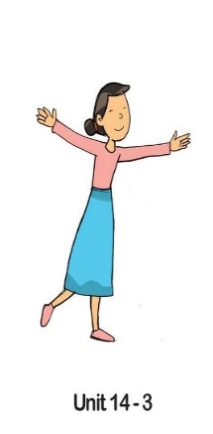 | 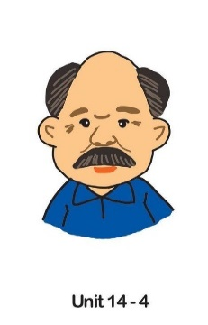 | 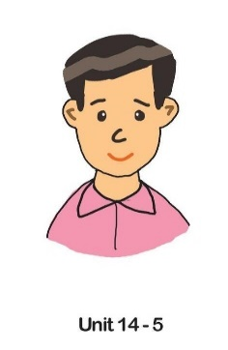 | 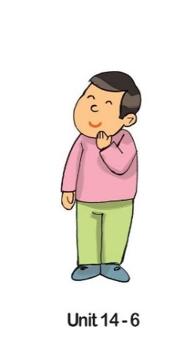

GV coi: ……………………………. GV chấm: …………………………….
…………………………………………………….............................................

