CAM PHUC PRIMARY SCHOOL  Full Name: .............................  Class: 5..... | THE END SEMESTER TEST  SUBJECT: ENGLISH - GRADE 5  School year: 2022 - 2023  (Time: 40 minutes)
Listening | Reading | Writing | Speaking | FINAL MARK | Comments
PART I: LISTENING (4 points)
Task 1. Listen and number. (1 point)
Examples:
a. | b. | c.
d. | e.
Task 2. Listen and tick A, B or C. (1 point)
Example: A. He has a starfruit tree. | B. He is greedy. | C. He is poor.

1. | A. She is kind. | B. She is white. | C. She’s one of the dwarfs.
2. | A. His name’s An Tiem. | B. He’s reading a story. | C. He’s hard-working.
3. | A. It’s fast. | B. It’s wise. | C. It’s slow.
4. | A. It’s tiny. | B. It’s giant. | C. It’s intelligent.
5. | A. It’s slow. | B. It’s careless. | C. It’s beautiful.
Task 3. Listen and tick the correct pictures. (1 point).
0. What does he like reading?
A. | 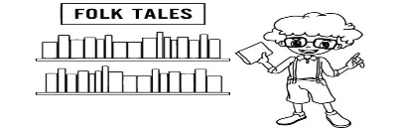  B. | C.
1. What is she reading?
A. | 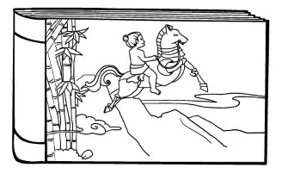  B. | 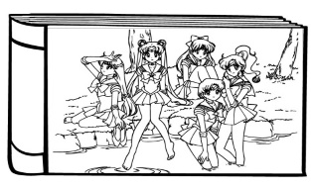  C.
2. Who is the main character?
A. | B. | C.
3. What’s his favourite story?
A. | B. | 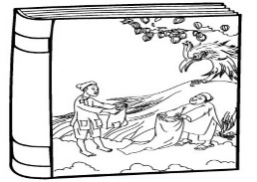  C.
4. Which animal does she think is stupid?
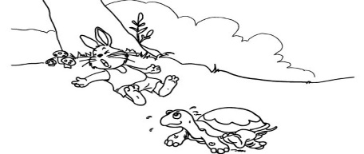  A. | B. | 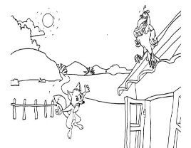  C.
5. Who won the race?
A. | 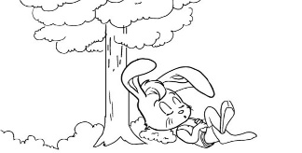  B. | 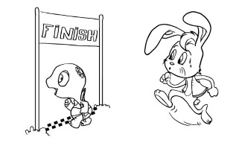  C.
Task 4. Listen and write R for Right or W for Wrong. (1 point)
0. Bill lives in London. | ____R___
1. His favourite season is summer. | _________
2. It’s sunny and wet in summer. | _________
3. Bill often travels in summer. | _________
4. He stayed in London last summer. | _________
5. He would like to visit a park in the north this year. | _________

PART II: READING (3 points)
Task 1. Read and tick True or False. (1 point)
My name is Lien. I live in Ha Noi, the capital city of Viet Nam. The city has a lot of tall buildings and wide roads. It is noisy and busy all day and night. Every summer, I go to Tam Dao, a town in Vinh Phuc Province, about 86 kilometres from Ha Noi. Tam Dao is smaller and quieter than Ha Noi. But it has a cool weather all year round like Da Lat. There are not many shops, but things are cheaper. I enjoy eating fresh vegetable and chicken here. These are delicious and healthy foods. I like breathing fresh air here, too. Life in Tam Dao is more peaceful than in Ha Noi.
 | True | False
0. Lien lives in the capital city of Viet Nam.
1. There are many tall buildings and wide roads in the city.
2. Ha Noi is usually noisy and busy in summer.
3. The weather in Tam Dao is often cooler than in Da Lat.
4. Vegetable and chicken are fresh and healthy foods in Tam Dao.
5. Lien enjoys the fresh air in Tam Dao.
Task 2. Read and number the sentences in the correct order. The conversation begins with 0. (1 point)
 | A | Mai: I think I will visit Cuc Phuong National Park.
0. | B | Hoa: Where did you go last summer holiday, Mai?
 | C | Mai: Yes, I did. It was more interesting than I expected.
 | D | Hoa: Wow, to the beach? Did you like the trip?
 | E | Mai: I went to the beach with my parents.
 | F | Hoa: How about this summer? Where would you like to visit?
Task 3. Read and fill each gap with one word from the box. Write the word next to the number. There is one word that you do not need. (1 point)
 | 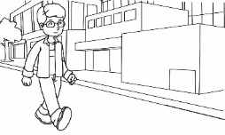 | 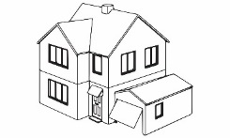
sunny | walk | house | reading
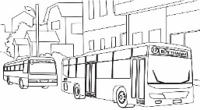
buses | writer | supermarket
Ben lives in a (0) house in a busy area. There are a lot of cars, (1) __________ and lorries in the street. Ben often goes shopping at a big and crowded (2) __________ opposite his house. There’s a bookshop on the corner of the street. Ben can (3) __________ there in ten minutes. He likes (4) __________ very much, so he goes to the bookshop every weekend. He would like to be a (5) __________ in the future. Ben likes the neighbourhood because he loves to see people and the busy life in the city.
III. WRITING (2 points)
Task 1. Look at the pictures and the example. Read the story and write the word(s) for each gap. (1 point)
0. | 1. | 2.
3. | 4. | 5.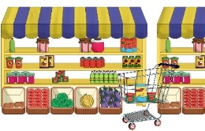
Dear Mai,
Tomorrow is Sunday. It will be (0) sunny. I’m happy because you’re going to visit us. You can take (1) _________ number 15 at South Street and get off at the third (2) _________. Then walk along West Street until you see North Street. Turn right and you will see the (3) _________ on the left. Our (4) two-storey ________ is between the post office and the (5) ________.
See you soon,
Jack
Task 2. Write a short letter to your friend and show her the way to get to you house. (1 point)
You can write about:
0. How do you feel when you know your friend is going to visit you?
1. What’s your address?
2. How long does it take to get to your house?
3. What means of transport can your friend take to get to your house?
4. From the post office, how can your friend get to your house?
5. Does your friend call you when she/he is near your house?
To: Anne Brown
215 Green Street, London
England
Dear Anne,
I’m very (0) happy you’re going to visit me in Viet Nam.
My address is (1) _______________________________________.
It takes about (2) _________________________ by bus or by (3) ________ to the city’s post office. From there you can (4) ___________________________.
Please (5) _________________________ when you are near my house.
See you soon.
Love,
Minh
PART III. SPEAKING (1 point)

GV coi: ……………………………. GV chấm: …………………………….
…………………………………………………….............................................

